**ПРАКТИЧЕСКОЕ ЗАДАНИЕ 26**

**ЯЗЫК РАЗМЕТКИ XAML**

Задание 1. Создать XML файл Магазин состоящий из товара (название товара, срок годности, стоимость).

Листинг программы:

public partial class MainWindow : Window

{

private readonly IXmlWorker _worker;

private readonly ILogger _logger;

public bool IsFileOpened = false;

private string _xmlFilePath;

public MainWindow()

{

InitializeComponent();

_logger = LoggerFactory.Create(builder => builder.SetMinimumLevel

(LogLevel.Information)).CreateLogger<MainWindow>();

_worker = new XmlDocumentWorker(_logger);

}

private void buttonFindCountryByName_Click(object sender, RoutedEventArgs e)

{

var market = _worker.FindBy(textBoxCountryName.Text);

PrintCountry(market);

}

private void buttonAdd_Click(object sender, RoutedEventArgs e)

{

PrintCountries(_worker.GetAll());

}

private void buttonExit_Click(object sender, RoutedEventArgs e)

{

this.Close();

}

private void buttonDelete_Click(object sender, RoutedEventArgs e)

{

if (!string.IsNullOrEmpty(textBoxDeleteCountryName.Text) || !string.IsNullOrWhiteSpace(textBoxDeleteCountryName.Text))

{

_worker.Delete(textBoxDeleteCountryName.Text);

PrintCountries(_worker.GetAll());

}

}

private void PrintCountry(Market markett)

{

textBlockXMLFileContent.Text = "=======Market========" + Environment.NewLine;

textBlockXMLFileContent.Text += markett?.ToString() ?? "Parking not found";

}

private void PrintCountries(List<Market> market)

{

textBlockXMLFileContent.Text = "========Tovar=======" + Environment.NewLine;

foreach (var markett in market)

{

textBlockXMLFileContent.Text += markett.ToString();

}

}

private void textBoxCountryName_TextChanged(object sender)

{

if (string.IsNullOrEmpty(textBoxCountryName.Text))

{

PrintCountries(_worker.GetAll());

}

}

private void buttonOpenFile_Click(object sender, RoutedEventArgs e)

{

var dialog = new OpenFileDialog();

dialog.InitialDirectory = Directory.GetParent(AppContext.BaseDirectory).Parent.Parent.FullName;

dialog.DefaultExt = ".xml";

dialog.Filter = "Xml documents(.xml)|*.xml";

var result = dialog.ShowDialog();

if (result.HasValue && result.Value)

{

_xmlFilePath = dialog.FileName;

textBlockXMLPathFile.Text = _xmlFilePath;

_worker.Load(_xmlFilePath);

PrintCountries(_worker.GetAll());

}

}

}

Анализ результатов:

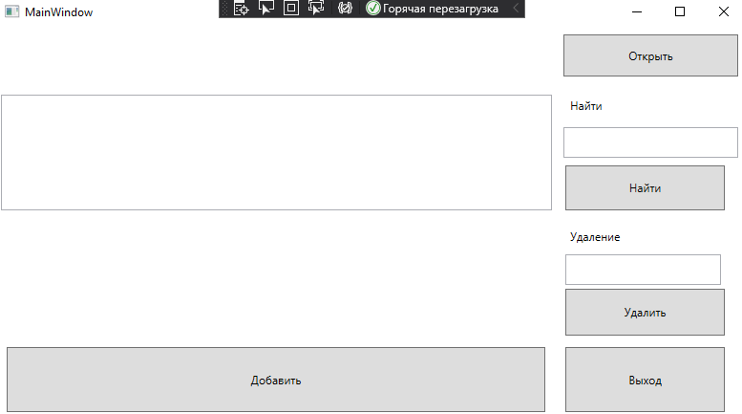

Рисунок 26.1 – Результат работы программы

Источник: собственная разработка